Experiment: Credit Score Classification
Aim
To implement a Credit Score Classification program in Python and classify customers into different credit-score categories based on their financial characteristics.
Procedure
- Import the required Python libraries.
- Create/load the credit-score dataset.
- Separate the input features and target class.
- Encode the categorical target values into numerical values.
- Split the dataset into training and testing sets.
- Train a classification model.
- Predict the credit score category for the test data.
- Calculate the accuracy of the model.
- Display the confusion matrix and classification results.
Python Program
import pandas as pd
from sklearn.model_selection import train_test_split
from sklearn.preprocessing import LabelEncoder
from sklearn.tree import DecisionTreeClassifier
from sklearn.metrics import accuracy_score, confusion_matrix
# Create Credit Score dataset
data = {
"Income": [25000, 30000, 45000, 50000, 60000,
70000, 80000, 35000, 40000, 90000,
55000, 28000, 75000, 65000, 32000],

"Debt": [20000, 18000, 10000, 8000, 5000,
3000, 2000, 15000, 12000, 1000,
6000, 19000, 2500, 4000, 17000],
"PaymentHistory": [1, 1, 2, 2, 2,
3, 3, 1, 2, 3,
2, 1, 3, 2, 1],
"CreditUtilization": [80, 70, 40, 30, 25,
15, 10, 65, 45, 8,
28, 75, 12, 20, 68],
"CreditScore": [
"Poor", "Poor", "Good", "Good", "Good",
"Excellent", "Excellent", "Poor", "Good",
"Excellent", "Good", "Poor", "Excellent",
"Excellent", "Poor"
]
}
# Create DataFrame
df = pd.DataFrame(data)
print("Credit Score Dataset:")
print(df)
# Separate features and target
X = df.drop("CreditScore", axis=1)
y = df["CreditScore"]
# Encode target labels
encoder = LabelEncoder()
y = encoder.fit_transform(y)

# Split dataset
X_train, X_test, y_train, y_test = train_test_split(
X, y, test_size=0.3, random_state=42
)

# Create Decision Tree classifier
model = DecisionTreeClassifier(
criterion="entropy",
random_state=42
)
# Train the model
model.fit(X_train, y_train)
# Predict
y_pred = model.predict(X_test)

# Display predictions
print("\nActual Values:")
print(encoder.inverse_transform(y_test))

print("\nPredicted Values:")
print(encoder.inverse_transform(y_pred))

# Accuracy
accuracy = accuracy_score(y_test, y_pred)

print("\nAccuracy:")
print(accuracy)

# Confusion Matrix
print("\nConfusion Matrix:")
print(confusion_matrix(y_test, y_pred))
Sample Output
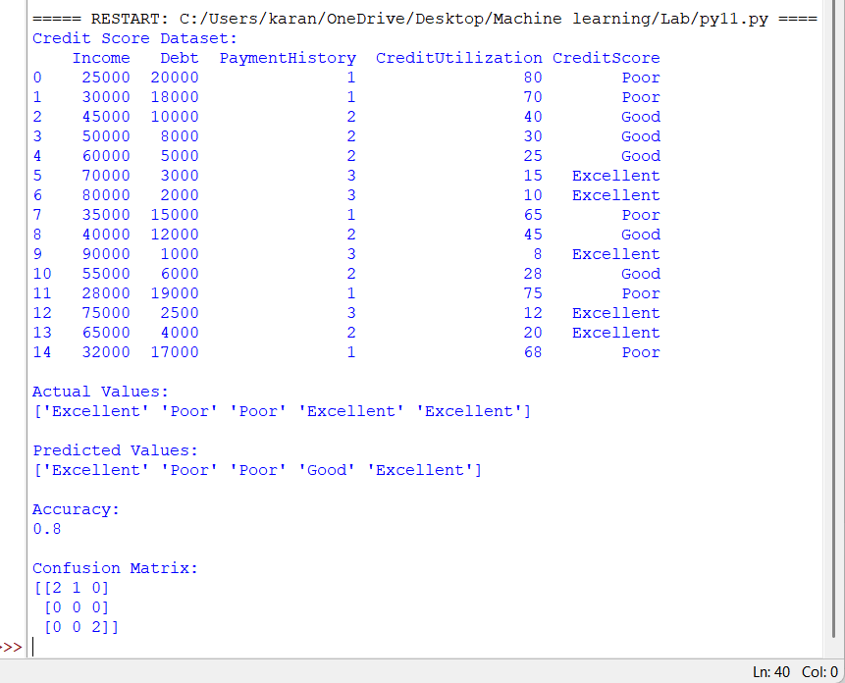
Result
The Credit Score Classification program was successfully implemented using a Decision Tree Classifier. The model classified customers into Poor, Good, and Excellent credit-score categories based on their income, debt, payment history, and credit utilization.

